CURD Operation
INSERT INTO inventory (product_name, quantity, seller_id)
VALUES ('Lip Balm', 25, 1);

SELECT * FROM inventory;

UPDATE inventory
SET quantity = 40
WHERE inventory_id = 7;

DELETE FROM inventory
WHERE inventory_id = 7;

Inventory Analysis Queries
Total Products Available
Explanation:
This query counts the number of products that are currently available in stock. Products with quantity greater than 0 are considered available.

SELECT COUNT(*) AS total_products
FROM inventory
WHERE quantity > 0;
Output:
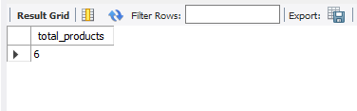

Products Out of Stock
Explanation:
This query counts the number of products that are currently available in stock. Products with quantity greater than 0 are considered available.
SELECT product_name, quantity
FROM inventory
WHERE quantity = 0;
Output:
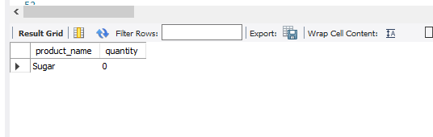

Highest Stocked Products
Explanation:
This query finds the product with the highest inventory quantity by comparing all product quantities.
SELECT product_name, quantity
FROM inventory
WHERE quantity = (SELECT MAX(quantity) FROM inventory);
Output:
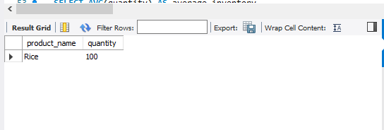

Average Inventory Quantity
Explanation:
This query calculates the average quantity of products available in the inventory.
SELECT AVG(quantity) AS average_inventory
FROM inventory;
Output:
